**Car Wash System**

**Intoduction:-**

The main objective of the Car wash System is to manage the customer car indicate them there is available slot for car going to wash. It manages all the information about Customer Address, Car. The project is built for both customer and shop owner end and thus only the shop owner has access to perform some changes in the there costing and some modifications. The purpose of the project is to build an application program to reduce the customer tension in urban areas to book a slot then go for wash in today’s era people are conscious of time that’s why it came into the picture to have less stress on customer and admin of particular shop. It tracks all the details about the Car and Customer.

**Software Requirement:-**

#### Java : Jdk-18, Spring Tool Suite

* + - Database : Mongo DB
    - Server : Web Server, Postman
    - Testing : Junit5

### Hardware Requirement :-

* + - Processor : Core i5
    - RAM : 8GB
    - Hard disk capacity : 25 GB

**Services:-**

1. Registration/ Login (JWT) 2. Customer or User service

3. Admin 4. API gateway

5. Eureka Service

**Diagram :-**

1. **Control Flow Diagram**

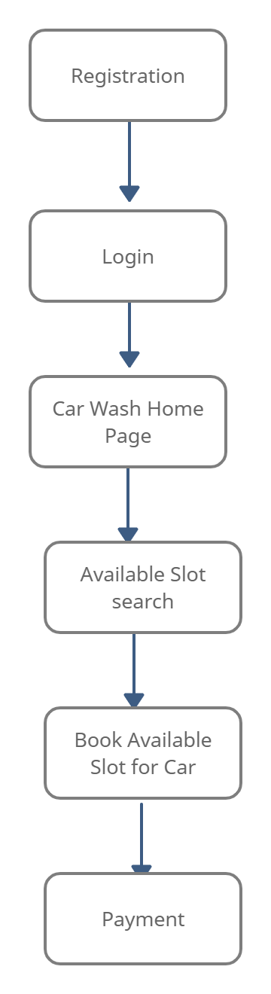

1. **User Flow**

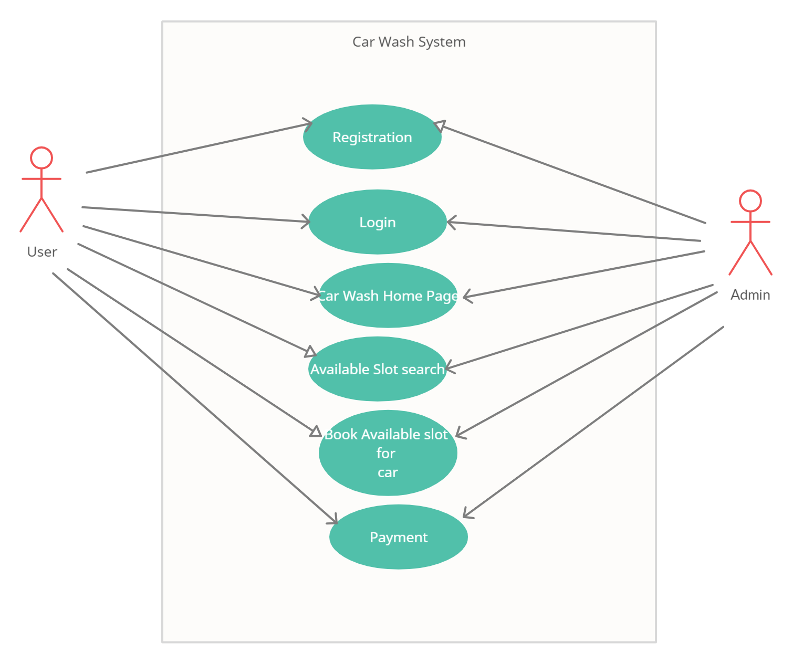

**3) Uml Diagram**

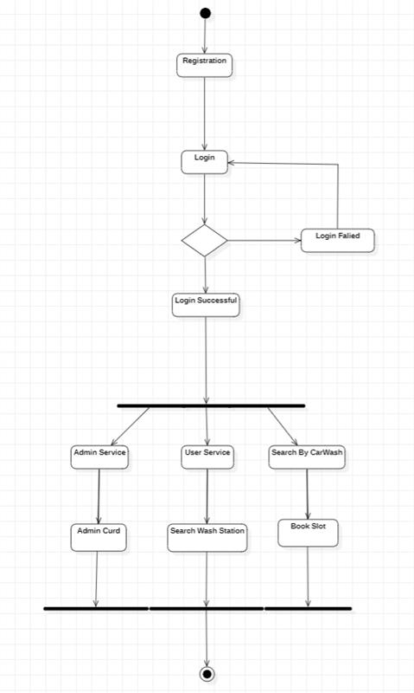

**User Story :-**

**Modules:**

* **Registration / Login:**
* **Admin login:** Admin is the one who administers the system by adding or removing cars into and from the system respectively.
* **User login:** Users have to register themselves into the system to create an account. After registering successfully, they can then login into the system.
* **User** can Search Carwash into a Carwash by using get or add operation.
* **Add and Update Cars:** The admin can add cars to the system by entering the details of the cars and can even update the details.
* **Search option:** Admin and user can even search for cars by entering the name of the car.
* **Eureka Services:**
* **Api Gateway:**

**Code Coverage:-**

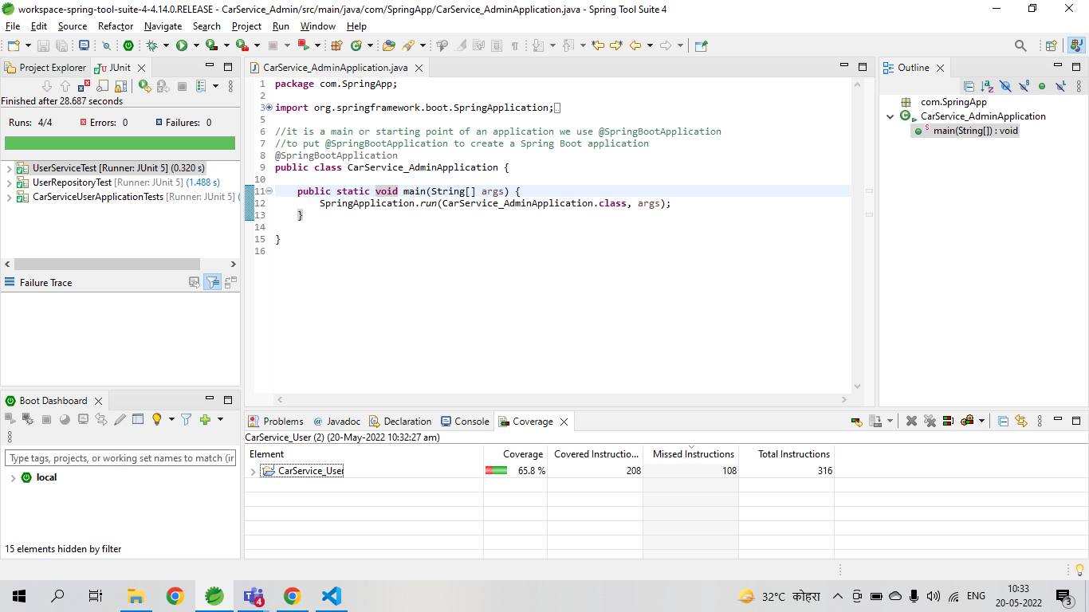

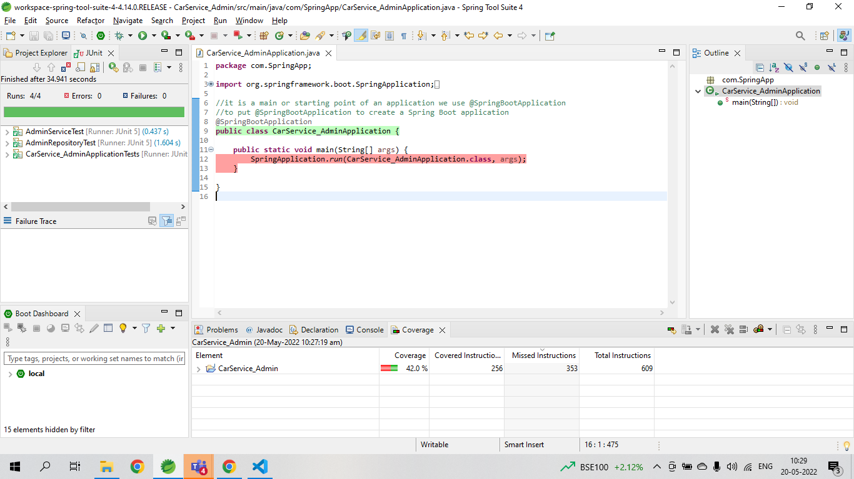

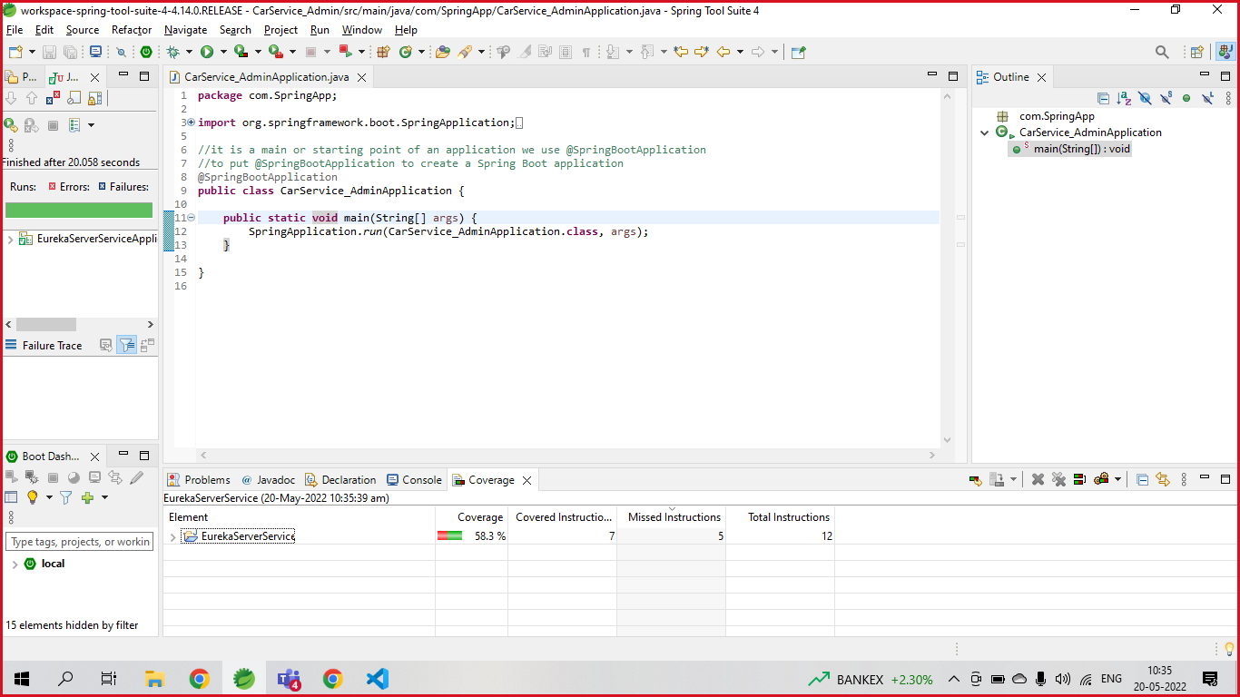

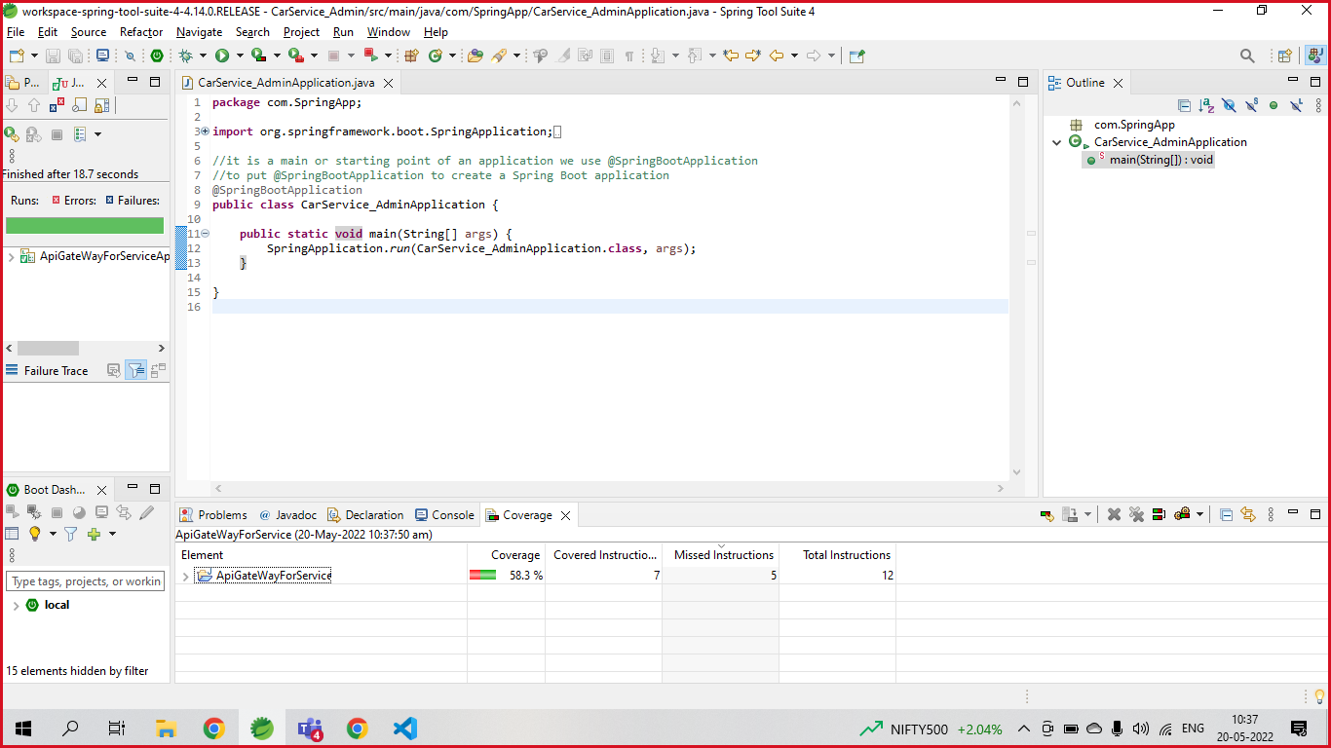

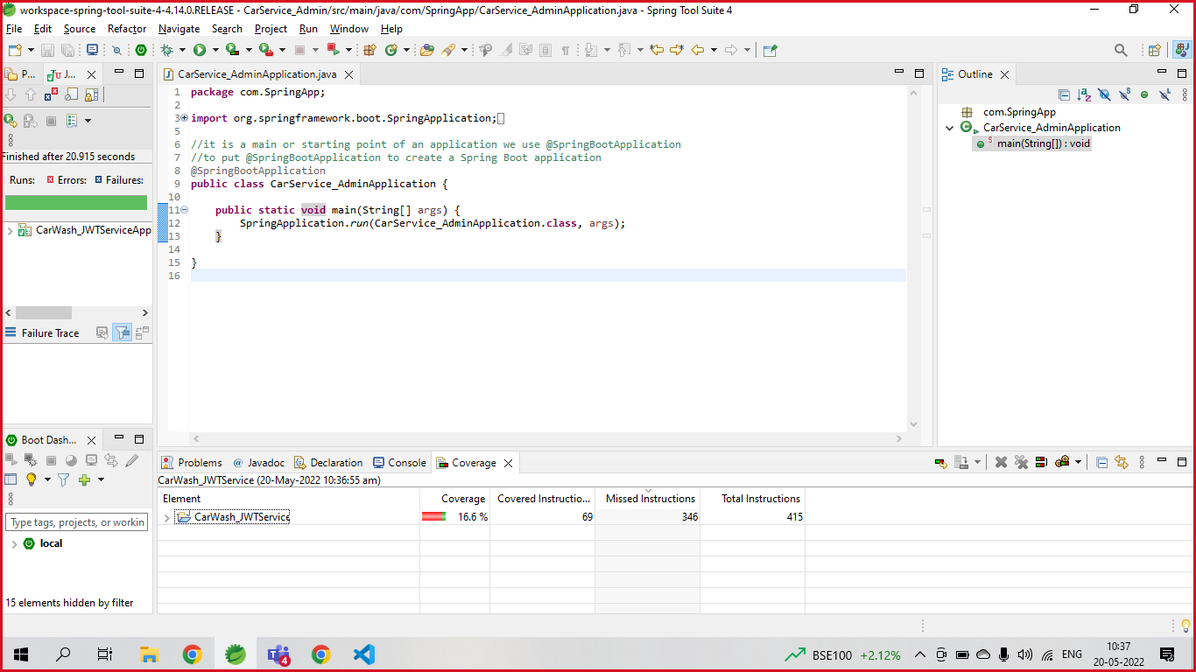

**Further Enhancements :-**

This software project is a car wash system with all the basic as well as some innovative features for managing or washing a car in detailed manner (mailing and notification via sms).

It consists of a large database of various types of cars (sedan, suv, sports, heavy vehicles) slot in the car wash system or app. It also lists various cars washed to respective customers.

The system keeps track of all the cars slot available and also the cars that have been washed to various customers for the review purpose in particular time.The system also handles cars detailed information database.

Thus this innovative car wash system provides an enhanced car wash functionality for this modern day world.

## Working Of On-Demand Car Wash Application

* The user logs into the app by social networking or an email address.
* A request is made for a car wash. At the time of submitting the inquiry, the type of vehicle wash is specified.
* The user’s application for a car wash is matched to local car wash service providers depending on the user’s current location.
* The request is accepted by interested car washing service suppliers.
* The user receives a push notice notifying him or her of the request’s approval.
* The car washing service provider will arrive at the user’s location according to the service schedule.
* Upon arrival, the application initiates a request for the car key.
* Furthermore, the application takes a photo of the automobile before it is washed.
* The car washer does the wash in accordance with the service order.

**Conclusion :-**

The evidence gathered in this report reflects ongoing progress toward more openness in car wash automation systems, but also that much work remains. We see a variety of options and opportunities. Car wash that expect to work with their automation system as delivered and not become involved in local extensions or programming will find that the majority of systems were built for that kind of use. For Car wash we want to do more with their automation systems, however, we see a great deal of functionality possible today through open interfaces with momentum toward creating much more.

With technology improvements, the on-demand service app market has received extensive attention. Owing to the increasing automotive software business, it’s quite probable that these car wash apps will have a bright future and thrive in the next few years.

## For Car Washers:-

### Enhancing Efficiency

Enhancing an organization’s efficiency results in increased performance and production. As demand for these apps increases, detailers have a greater understanding of the consumers’ expectations. They can keep track of which aspects of their service are most popular with users. It will increase the productivity and increase the growth of the car washer and it makes easy for users also

### Avoid Inconvenient Situations

These applications assist car washers in establishing a positive reputation in the industry. Positive word of mouth might assist them in excelling in a certain place. Additionally, the input supplied by consumers online assists them in growing in their location.